HD 47186

HD 47186 is a 0.99 M☉, G5 V star1. Based on 66 RV HARPS measurements obtained between 2003 and 2008, a study performed in 2008 (hereafter B08)1 reported a Hot Jupiter (HD 47186b) signal with a period of 4.0845 ± 0.0002 days, a minimum mass 0.07167 MJup and an eccentricity of 0.038 ± 0.02 as well as a GP (HD 47186c) signal with a period of 1353.6 ± 57.1 days, a minimum mass of 0.35 MJup and an eccentricity of 0.249 ± 0.073. The CH survey reported properties close to those reported in B08 for HD 47186b, and different properties for HD 47186c, with a period of 3552 days, a minimum mass of 0.58 MJup and an eccentricity of 0.28.

In the present study, in addition to the B08’s dataset, 105 RV measurements obtained with HARPS between 2003 and 2017 and 67 HIRES RV measurements obtained between 2004 and 2014 were considered. While only one minimum of HD 47186c was observed in the B08 dataset, a minimum and a maximum are now covered. However, the orbital phase is not yet fully covered. DPASS and MCMC (1000 walkers and 400000 iterations) were used to fit the data. To converge more easily, the priors on the semi-major axis and the minimum mass of the short period planet HD 47186b were chosen close to the values found in the B08 study. The properties of planet b are, expectedly, close to those reported in the B08 study. For HD 47186c, a period of 83984 days, a minimum mass of 0.64 MJup and an eccentricity of 0.93 were found with DPASS, with a corresponding rms of residuals of 3 m/s, and a period between 9790 and 42000 days, a minimum mass of 0.63 ± 0.05 MJup and an eccentricity of were found using MCMC. The period of HD 47186c is then significantly different from previously published values. It is actually poorly constrained.

To explore the range of possible values, the semi-major axis was fixed to different values and the data fitted with DPASS. *a* up to 100 au do not significantly change the rms of the residuals (3.3 m/s against 3 m/s with *a* left free). In this case (referred to as constrained *a*), the minimum mass is 0.98 MJup and the extremely high eccentricity is 0.95. As the RV curve of HD 47186c covers a maxima and a minima, the stellar offset is well constrained and changing it will not change the possible values beyond those found with the constrained *a*.

The fits are shown in Fig 1, and the corner plot in Fig 2, and the results summarized in Table 1.

Conclusion: The properties found in the CH survey for HD 47186c are not confirmed. Additional data are needed to further constrain its orbital properties.

Figure 1: Left: fit of the HD 47186 RV with DPASS. Red - H03, green - H15, blue - Hir94, cyan - Hir04. The blue curve shows the best fit. Middle: fit of the HD 47186 RV with DPASS, with the minimum *a* fixed at 100 au. The points are the same as on the left. The blue curve shows the best fit. Right: fit of the HD 47186 RV using MCMC. The black curves show the best fit. The gray dotted line indicates the end of the CH survey.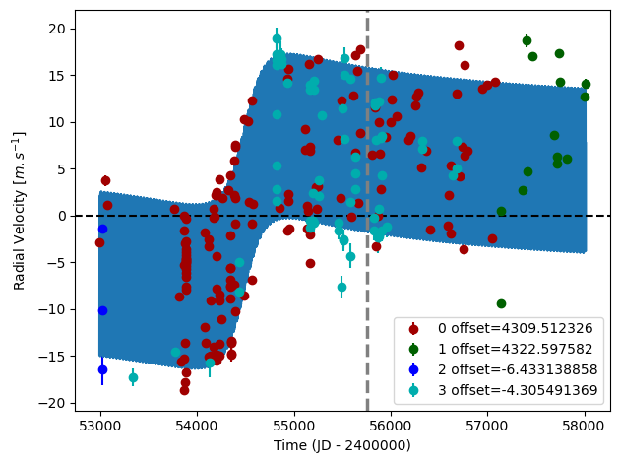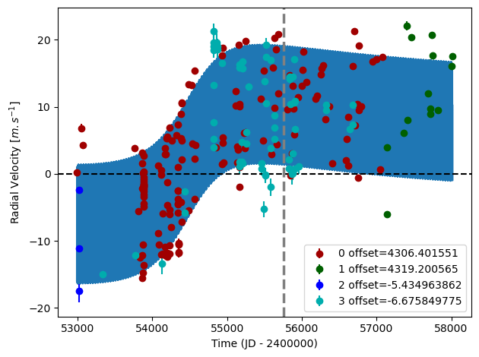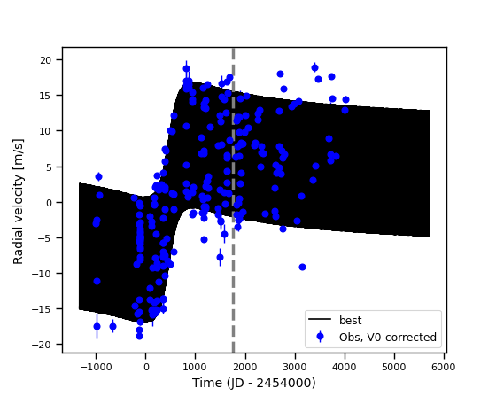

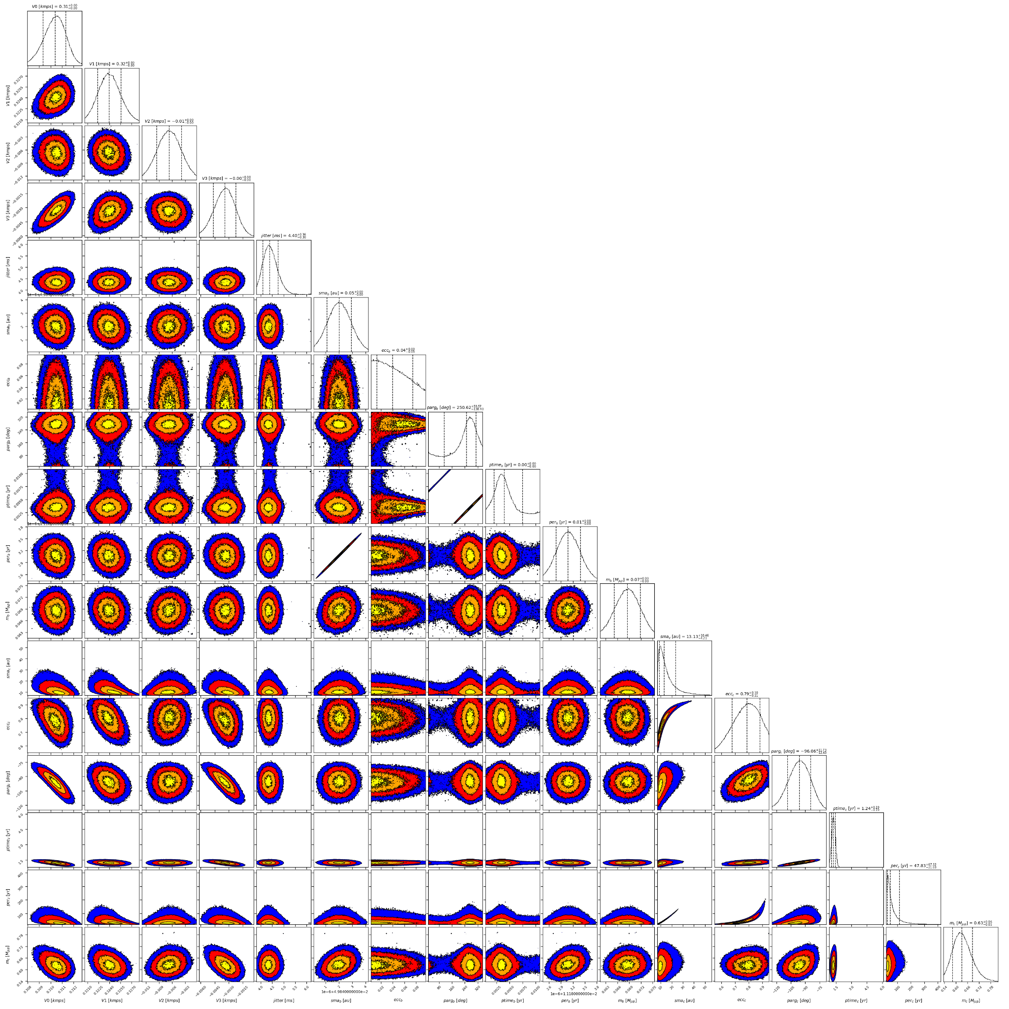

Figure 2: Corner plot of posteriors for the two-planets model MCMC fit of HD 47186 RV data.

| Parameter | Priors | | | Posteriors | | | CH survey |
| --- | --- | --- | --- | --- | --- | --- | --- |
|  | DPASS | | MCMC | DPASS | | MCMC |  |
|  | Free *priors* | Constrained *a* | Free priors | Free priors | Constrained *a* | Free priors |  |
| *a* (au) | b: [0,0.1]  c: [0,80] | b: [0,0.1]  c: up to 100 | b: [0.01,0.1]  c: [1,500] | b = 0.05  c = 37.4 | b = 0.05  c = 100 | b = 0.050 ± 0.001  c = 9 – 24 | b = 0.05  c = 4.5 |
| Msin(i) (MJup) | b: [0,0.1]  c: [0,100] | b: [0,0.1]  c: [0,1] | b: [0.01,0.1]  c: [0.1,2] | b = 0.073  c = 0.64 | b = 0.073  c = 0.98 | b = 0.069+0.003-0.004  c = 0.63 ± 0.05 | b = 0.072  c = 0.58 |
| Eccentricity | b: [0,0.6]  c: [0,0.95] | b: [0,0.6]  c: [0,0.95] | b: [0,0.2]  c: [0.1,0.99] | b = 0.06  c = 0.93 | b = 0.06  c = 0.95 | b < 0.07  c = 0.79+0.09-0.11 | b = 0.04  c = 0.28 |
| Instrumentals offsets (km/s) | [-60,60] | [-60,60] | H03: [3,5]  H15: [3,5]  Hir94: [-1,1]  Hir04: [-1,1] | H03: 4.310  H15: 4.322  Hir94: -0.006  Hir04: -0.004 | H03: 4.306  H15: 4.319  Hir94: -0.005  Hir04: -0.007 | H03: 4.310 ± 0.001  H15: 4.324 ± 0.002  Hir94: -0.007 ± 0.003  Hir04: -0.003 ± 0.001 |  |
| Stellar jitter (m/s) | [0,40] | [0,40] | [0,20] | 4.1 | 4.5 |  |  |
| Argument of periastron (°) | b: [0,360]  c: [0,360] | b: [0,360]  c: [0,360] | b: [0,360]  c: [0,360] | b = 278  c = 273 | b = 253  c = 281 | b = 112 – 311  c = 262 – 276 |  |
| Phase | b: [0,1]  c: [0,1] | b: [0,1]  c: [0,1] | b: [0,1]  c: [0,1] | b = 0.81  c = 0.65 | b = 0.43  c = 0.15 | b = 0.18 – 0.67  c = |  |

Table 1: Summary of priors and posteriors obtained for the HD 47186 RV with a genetic algorithm (DPASS) and those obtained with an MCMC, compared to the properties reported by the CH Survey.

References

1. Bouchy, F. et al. The HARPS search for southern extra-solar planets. XVII. Super-Earth and Neptune-mass planets in multiple planet systems HD 47 186 and HD 181 433. Astron. Astrophys. 496, pp.527-531 (2009).